Experiment No. 2a): Real-Time Heart Rate Stream Analytics and High–Low Anomaly Detection using Python (Google Colab)

AIM
To design and implement a real-time heart rate stream analytics system and perform high and low heart rate anomaly detection using Python in Google Colab.

SOFTWARE REQUIRED
- Google Colab
- Python 3
- pandas
- matplotlib
- numpy

Procedure
- Open Google Colab and create a new notebook.
- Import the required Python libraries such as Pandas and Matplotlib.
- Create or load the heart rate dataset containing Heart Rate (BPM) readings.
- Store the dataset in a pandas DataFrame.
- Display the heart rate dataset.
- Compare each heart rate reading with the predefined threshold values.
- Classify each reading as Low Anomaly (Heart Rate < 60 BPM), Normal (60–100 BPM), or High Anomaly (Heart Rate > 100 BPM).
- Count the number of normal, low anomaly, and high anomaly readings.
- Display the classified heart rate data.
- Visualize the heart rate readings using graphs with threshold lines to highlight anomalies.
- Save the processed heart rate data as a CSV file for future analysis.
- Observe the output and conclude the experiment.

THEORY
Heart rate monitoring is an important application in IoE healthcare systems. Sensor data is continuously collected and analyzed to detect abnormal heart rate conditions.
In this experiment, heart rate data is generated and analyzed in real time using Python. The system classifies heart rate readings as Normal, Low Anomaly, or High Anomaly based on predefined threshold values.

Heart Rate Categories:
- Heart Rate < 60 BPM → Low Anomaly (Bradycardia)
- Heart Rate = 60–100 BPM → Normal
- Heart Rate > 100 BPM → High Anomaly (Tachycardia)
The collected data is stored, analyzed, and visualized using line graphs with threshold lines.

SAMPLE DATA
Time | Heart Rate (BPM)
1 | 72
2 | 78
3 | 55
4 | 80
5 | 98
6 | 110
7 | 76
8 | 58
9 | 125
10 | 85

ALGORITHM
- Start the program.
- Generate heart rate readings.
- Store the heart rate data.
- Display the dataset.
- Compare each reading with threshold values.
- If heart rate < 60 BPM, mark it as Low Anomaly.
- If heart rate > 100 BPM, mark it as High Anomaly.
- Otherwise, mark it as Normal.
- Plot the heart rate graph with threshold lines.
- Highlight anomalies on the graph.
- Display the number of normal, low, and high anomaly readings.
- Stop the program.
Phytho code
# Sensor Data Acquisition and Preprocessing using Python

import pandas as pd
import matplotlib.pyplot as plt

# ----------------------------
# Step 1: Create Sensor Dataset
# ----------------------------
sensor_data = {
"Temperature":[28,29,30,31,29],
"Humidity":[65,66,68,69,67],
"Pressure":[1012,1011,1010,1013,1011],
"HeartRate":[78,80,81,79,80],
"SpO2":[98,99,97,98,99]
}

df = pd.DataFrame(sensor_data)

# Save dataset
df.to_csv("sensor_data.csv", index=False)

# ----------------------------
# Step 2: Read Dataset
# ----------------------------
df = pd.read_csv("sensor_data.csv")

print("Original Dataset")
print(df)

# ----------------------------
# Step 3: Data Preprocessing
# ----------------------------

# Check missing values
print("\nMissing Values:")
print(df.isnull().sum())

# Remove duplicate rows
df = df.drop_duplicates()

# Display cleaned dataset
print("\nCleaned Dataset")
print(df)

# Statistical Summary
print("\nStatistical Summary")
print(df.describe())

# ----------------------------
# Step 4: Data Visualization
# ----------------------------

# Temperature
plt.figure(figsize=(6,4))
plt.plot(df["Temperature"], marker='o')
plt.title("Temperature")
plt.xlabel("Sample")
plt.ylabel("Temperature (°C)")
plt.grid()
plt.show()

# Humidity
plt.figure(figsize=(6,4))
plt.plot(df["Humidity"], marker='o')
plt.title("Humidity")
plt.xlabel("Sample")
plt.ylabel("Humidity (%)")
plt.grid()
plt.show()

# Heart Rate
plt.figure(figsize=(6,4))
plt.bar(df.index, df["HeartRate"])
plt.title("Heart Rate")
plt.xlabel("Sample")
plt.ylabel("Heart Rate (BPM)")
plt.show()

# SpO2
plt.figure(figsize=(6,4))
plt.bar(df.index, df["SpO2"])
plt.title("SpO2")
plt.xlabel("Sample")
plt.ylabel("SpO2 (%)")
plt.show()

# Pressure
plt.figure(figsize=(6,4))
plt.plot(df["Pressure"], marker='o')
plt.title("Pressure")
plt.xlabel("Sample")
plt.ylabel("Pressure (hPa)")
plt.grid()
plt.show()

print("\nExperiment Completed Successfully!")

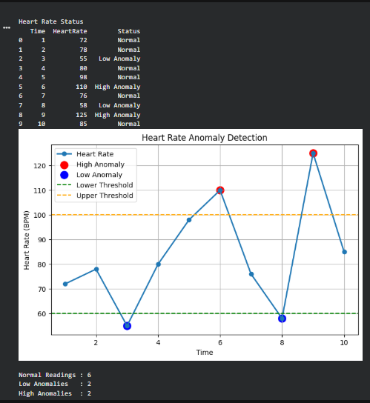

RESULT
The real-time heart rate stream analytics system successfully generated heart rate data, analyzed the readings, detected both low and high heart rate anomalies using predefined threshold values, and visualized the results using Python in Google Colab. The experiment demonstrates how real-time health monitoring can identify abnormal heart rate conditions and support IoE-based healthcare applications.

Experiment No. 2: Smart Parking Slot Occupancy Monitoring using Python (Google Colab)

AIM
To design and implement a smart parking slot occupancy monitoring system for analyzing the status of parking slots and identifying vacant and occupied parking spaces using Python in Google Colab.

SOFTWARE REQUIRED
- Google Colab
- Python 3
- pandas
- matplotlib
- random
PROCEDURE
- Open Google Colab and create a new notebook.
- Import the required Python libraries such as random, Pandas, and Matplotlib.
- Specify the total number of parking slots.
- Generate the parking slot occupancy status randomly as Occupied or Vacant.
- Store the parking slot number and occupancy status in separate lists.
- Create a pandas DataFrame using the generated parking slot data.
- Display the parking slot dataset.

THEORY
Smart parking systems are an important application of the Internet of Everything (IoE) that helps monitor parking space availability in real time. Sensors installed in parking slots detect whether a slot is occupied or vacant, enabling efficient parking management and reducing traffic congestion.
In this experiment, parking slot occupancy data is simulated using Python. Each parking slot is randomly assigned as Occupied or Vacant, and the system analyzes the parking status by counting the total number of occupied and vacant slots. If the number of occupied slots exceeds a predefined threshold, the parking area is classified as High Traffic; otherwise, it is classified as Normal. The parking occupancy data is stored and visualized using a bar chart.

Parking Slot Categories
- Occupied → Parking slot is occupied by a vehicle.
- Vacant → Parking slot is available.
- Occupied Slots > 85 → High Traffic.
- Occupied Slots ≤ 85 → Normal.

SAMPLE DATA
Parking Slot | Status
1 | Occupied
2 | Vacant
3 | Occupied
4 | Occupied
5 | Vacant
6 | Occupied
7 | Occupied
8 | Vacant
9 | Occupied
10 | Vacant

ALGORITHM
- Start the program.
- Import the required Python libraries.
- Specify the total number of parking slots.
- Generate the parking slot status randomly as Occupied or Vacant.
- Store the parking slot number and status.
- Create a dataset using a pandas DataFrame.
- Display the parking slot dataset.
- Count the total occupied and vacant parking slots.
- Display the parking occupancy summary.
- Check the traffic condition based on occupied slots.
- Save the parking slot data as a CSV file.
- Visualize the parking slot occupancy using a bar chart.
- Stop the program.
Phython code :
import random
import pandas as pd
import matplotlib.pyplot as plt
num_slots = 100
slot_number = []
status = []
vacant_slots = []
occupied_slots = []
for i in range(1, num_slots + 1):
# 70% Occupied, 30% Vacant
if random.random() < 0.7:
s = "Occupied"
occupied_slots.append(i)
else:
s = "Vacant"
vacant_slots.append(i)
slot_number.append(i)
status.append(s)
# Create DataFrame
df = pd.DataFrame({
"Parking Slot": slot_number,
"Status": status
})
print(df)
print("\n========== PARKING SUMMARY ==========")
print("Total Slots :", num_slots)
print("Occupied Slots :", len(occupied_slots))
print("Vacant Slots :", len(vacant_slots))
print("\nVacant Slot Numbers:")
print(vacant_slots)
print("\nOccupied Slot Numbers:")
print(occupied_slots)
if len(occupied_slots) > 85:
print("\nParking Status : HIGH TRAFFIC")
else:
print("\nParking Status : NORMAL")
# Save CSV
df.to_csv("parking_slots.csv", index=False)
# Plot
plt.figure(figsize=(14,4))
colors = ['red' if x=="Occupied" else 'green' for x in status]
plt.bar(slot_number, [1]*num_slots, color=colors)
plt.xlabel("Parking Slot Number")
plt.title("Smart Parking Occupancy")
plt.yticks([])
plt.show()
Output :
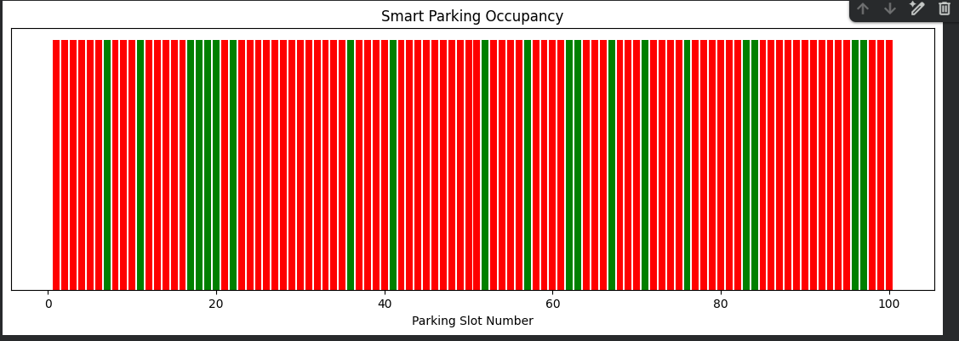

RESULT
The smart parking slot occupancy monitoring system successfully generated parking slot occupancy data, analyzed the status of parking slots, identified vacant and occupied parking spaces, displayed the parking occupancy summary, and visualized the results using Python in Google Colab. The experiment demonstrates how IoE-based smart parking systems can efficiently monitor parking availability and support intelligent parking management.

